**Experiment-1**

1. **To interface LED / Buzzer with Arduino / Raspberry Pi and write a program to “turn ON” LED for 1 sec after 2 seconds.**

**Pin connections:**

connect pin 9 of Arduino board to LED (RED/BLUE/GREEN)

1. **To interface Push button/ Digital sensor (IR / LDR) with Arduino /Raspberry Pi and write a program to ‘Turn ON’ LED when Push button is pressed or at sensor detection**

**Connections:**

pin D12 to LED, D2 to SW2, GND (optional)

**Experiment-2**

1. **To interface DHT11 sensor with Arduino / Raspberry Pi and write a program to print temperature and humidity readings.**

**Pin Connection:**

|  |  |
| --- | --- |
| **Arduino** | **LCD** |
| D12 | RS |
| D11 | EN |
| D10 | D4 |
| D9 | D5 |
| D8 | D6 |
| D7 | D7 |

RW (LCD) to GND, VCC (LCD) to +5V

**DHT11 Sensor connections:**

GND to GND, DATA to D2 (Arduino), VCC to +5V

**ii)To interface OLED with Arduino / Raspberry Pi and write a program to print temperature and humidity readings**

**Pin Connections:**

|  |  |
| --- | --- |
| **DHT11** | **ARDUINO** |
| DATA | D2 |
| **DHT11** | **BOARD** |
| GND | GND |
| VCC | +5V |

|  |  |
| --- | --- |
| **OLED** | **ARDUINO** |
| VDD | 3V3 |
| SCK | A5 |
| SDA | A4 |
| GND | GND |

**Experiment-3**

**To interface motor using relay with Arduino / Raspberry Pi and write a program to ‘turn ON’ the motor when push button is pressed.**

**Hardware Connections:**

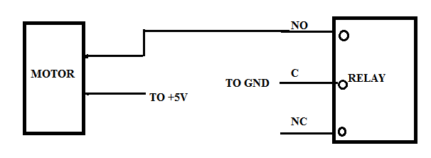**NO- Normally Open C- Common NC- Normally Closed**

* **Connect push button to pin D7 and RLIN to pin D3**

**Experiment-4**

**a) Write An Arduino Program To Interface The Soil Moisture Sensor**

**Pin Connection:**

|  |  |
| --- | --- |
| Soil moisture sensor | Arduino |
| A0 | A0 |

VCC to +5v ,GND to GND

**b)Write an Arduino program to interface the LDR/photo sensor.**

**Pin Connection:**

|  |  |
| --- | --- |
| **LDR MODULE** | **ARDUINO** |
| LDR_OUT | A0 |
| GND | GND |

* LED TO A2.

**Experiment-5**

**Write a program to interface an ultrasonic sensor with Arduino.**

**Pin Connection:**

|  |  |
| --- | --- |
| **Ultrasonic sensor** | **Arduino** |
| TrigPin | D9 |
| EchoPin | D10 |

GND TO GND , VCC to +5V

**Experiment-6**

**Write a program on Arduino / Raspberry Pi to upload temperature and humidity data to using Thing speak cloud**

**Pin Connections:**

|  |  |
| --- | --- |
| **DHT11** | **ESP8266** |
| DATA | D5 |
| **DHT11** | **BOARD** |
| GND | GND |
| VCC | +5V |

**Experiment-7**

**Write a program on Arduino / Raspberry Pi to receive temperature and humidity data from Thing speak cloud.**

**Experiment-8**

|  |  |
| --- | --- |
| **DHT 11 sensor** | **ESP8266** |
| DATA | D6 |
| GND | GND |
| VCC | +5v |

**Write a program on Arduino / Raspberry Pi to publish temperature data to MQTT broker.**